JUnit Basic Testing Exercises

Exercise 1: Setting Up JUnit

import org.junit.Test;
import static org.junit.Assert.*;

public class CalculatorTest {

@Test
public void testAddition() {
int result = 2 + 3;
assertEquals(5, result);
}
}

OUTPUT:

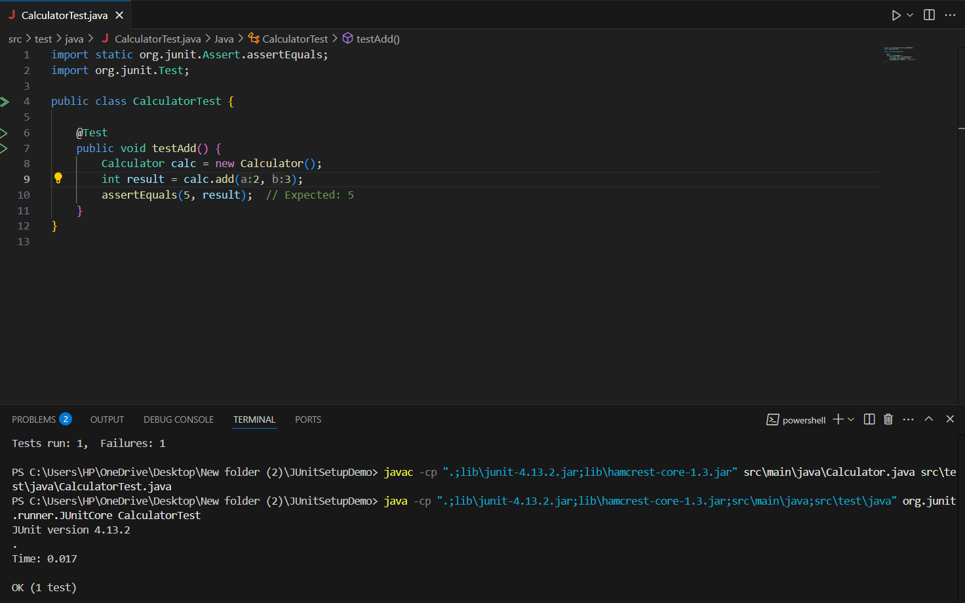

======================================================================

Exercise 3: Assertions in JUnit

import org.junit.jupiter.api.Test;
import static org.junit.jupiter.api.Assertions.*;

public class AssertionsTest {

Assertions calc = new Assertions();

@Test
public void testAllAssertions() {

assertEquals(5, calc.add(2, 3));

assertNotEquals(6, calc.add(2, 3));

assertTrue(calc.isPositive(10));

assertFalse(calc.isPositive(-5));

assertNull(calc.getNullString());

assertNotNull(calc.getNonNullString());

}
}

OUTPUT:

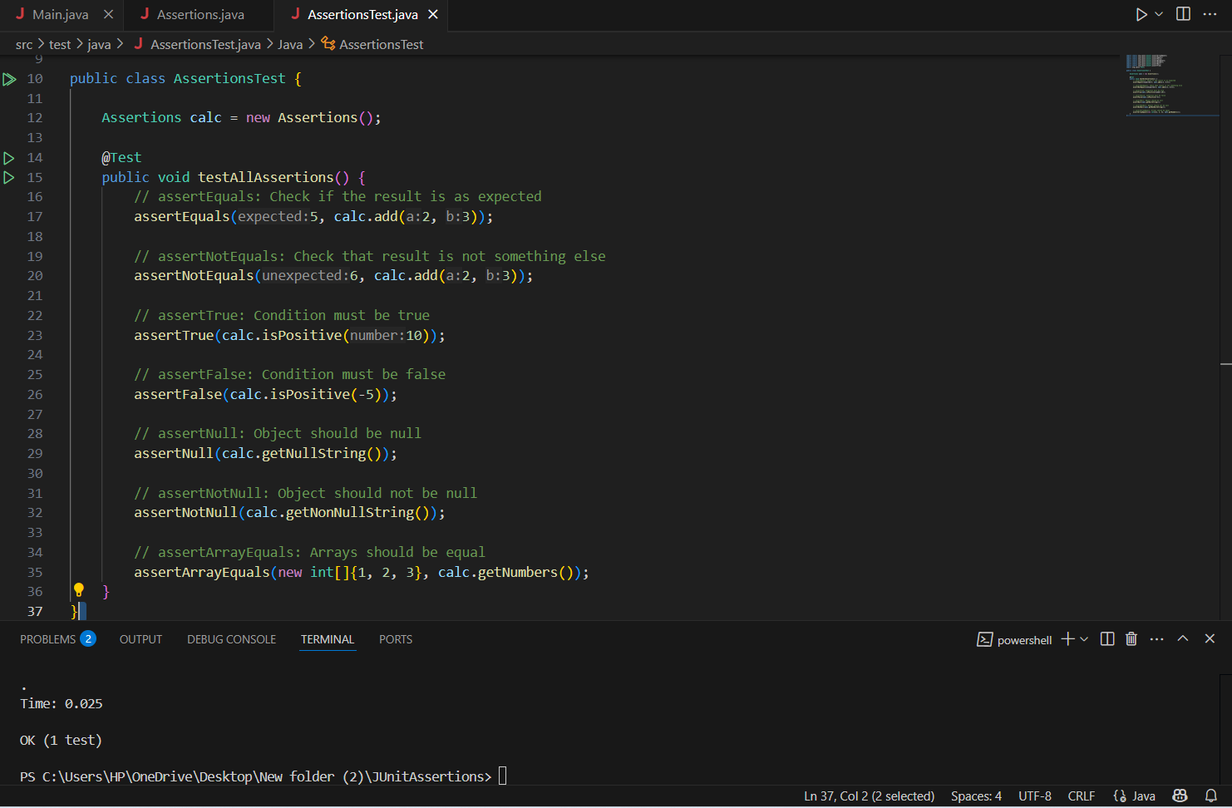
======================================================================
Exercise 4: Arrange-Act-Assert (AAA) Pattern, Test Fixtures, Setup and Teardown Methods in JUnit

import org.junit.After;
import org.junit.Before;
import org.junit.Test;
import static org.junit.Assert.assertEquals;

public class CalculatorTest {

private Calculator calculator;
@Before
public void setUp() {
calculator = new Calculator();
System.out.println("Setup complete.");
}
@After
public void tearDown() {
calculator = null;
System.out.println("Teardown complete.");
}
@Test
public void testAdd() {
int result = calculator.add(10, 5);
assertEquals(15, result);
}
@Test
public void testSubtract() {
int result = calculator.subtract(10, 3);
assertEquals(7, result);
}
}

OUTPUT:





